

REPUBLIC OF ZAMBIA

**Office of the President**

SMART ZAMBIA INSTITUTE

**(Property of the Government of Zambia)**

**SMART DEPARTMENT**

**BUSINESS REQUIREMENTS DOCUMMENT**

**Prepared by:**

**Smart Zambia Institute**

January, 2021

**BUSINESS REQUIREMENTS DOCUMENT**

**Table of Contents**

INTRODUCTION 4

1.1 INSTITUTIONAL CONTEXT 4

1.2 BACKGROUND 5

1.3 PROJECT VISION / SUMMARY 6

1.4 DOCUMENT PURPOSE 6

2 7

BUSINESS CASE 7

2.1 PROBLEM STATEMENT 7

2.2 CHALLENGES THE MINISTRY IS CURRENTLY FACING 7

2.3 SCOPE OF THE REQUIREMENT 10

2.4 ATTRIBUTES OF PROPOSED SOLUTION 10

2.5 STAKEHOLDER LIST 12

3 15

OPERATIONAL REQUIREMENTS 15

3.1 BUSINESS DRIVERS 15

3.2 HIGHLEVEL BUSINESS PROCESS 15

3.3 PROPOSED FUNCTIONAL REQUIREMENTS 15

3.4 NON-FUNCTIONAL REQUIREMENTS 17

3.1 NON-FUNCTIONAL REQUIREMENTS 17

4 20

SERVICE AND SUPPORT 20

4.1 END-USER OPERATIONAL SUPPORT 20

4.2 DOCUMENTATION 20

4.3 SOFTWARE MAINTENANCE & UPGRADES 21

5 22

COSTING PARAMETERS 22

5.1 SOFTWARE LICENCING 22

5.2 IMPLEMENTATION PLAN 22

5.3 TRAINING 23

**Change Record**

|  |  |  |  |
| --- | --- | --- | --- |
| Date | Author | Version | Change Reference |
| 14-09- 2020 | Chewe Nkole | 0.1 Draft | Document Creation. |
|  |  |  |  |
|  |  |  |  |
|  |  |  |  |
|  |  |  |  |
|  |  |  |  |

**Reviewers**

|  |  |  |  |
| --- | --- | --- | --- |
| Name | Version Approved | Position | Date |
| Dr David Phiri |  | Director, Systems Development and Support |  |
| Milner Makuni |  | Director, eGovernment |  |
|  |  |  |  |
|  |  |  |  |
|  |  |  |  |
|  |  |  |  |

|  |  |
| --- | --- |
|  | **INTRODUCTION** |

## **INSTITUTIONAL CONTEXT**

Importance an need of this system.

## **DOCUMENT PURPOSE**

This document is a business requirements document (BRD) and its role is to define requirements for the development of Smart Department. This document will outline the information flow for the various modules identified during the Business requirements gathering.

## **BACKGROUND**

The Ministry of National Guidance and Religious Affairs (MNGRA) was created by His Excellency the President of the Republic of Zambia, Dr Edgar Chagwa Lungu, on 28th August, 2016 and ratified by Parliament on 27th October, 2017.

The Ministry was created to spearhead and coordinate:

1. The promotion of National Values and Principles; and
2. The actualization of the declaration of Zambia as a Christian Nation.

The specific portfolio functions of MNGRA according to Government Gazette Notice No. 836 of 2016, Vol. LII. No. 76 and the Constitution Amendment Act No. 2 of 2016, include:

1. Christian Affairs;
2. Interdenominational Dialogue;
3. National Guidance;
4. National values, principles and ethics;
5. Public Religious Celebrations;
6. Preservation of Christian and Religious Sites; and
7. Religious Affairs.

Since its inception, the Ministry of National Guidance and Religious Affairs has been operating without a legal framework for the implementation of its mandate. However, the Ministry developed the National Values and Religious policy which will soon be launched.

Currently, Churches, Church Umbrella Bodies, Faith Based Organizations and Religious bodies are registered by the Registrar of Societies under the Societies Act, Chapter 119 of the Laws of Zambia, in the Ministry of Home Affairs. Under the Societies Act, a society is any club, company, partnership or other association of ten or more persons, whatever its nature. In this whole process MNGRA does not have a legal role. However, Churches, Church Mother Bodies, Faith Based Organizations and Religious Umbrella Bodies have their own unique attributes which are not adequately regulated by the Societies Act of 2009.

In order to address the identified gaps, the Ministry of National Guidance and Religious Affairs has been collaborating with the Registrar of Societies in the Ministry of Home Affairs on matters relating to Church Mother Bodies and Other Religious Bodies. An administrative arrangement has been put in place that requires that before new churches and religious organizations are registered, the Ministry of National Guidance and Religious Affairs need to vet and provide appropriate recommendation.

The Ministry further collaborates with the Ministry of Commerce, Trade and Industry to ensure that all Churches and Religious Bodies registered under Patents and Companies Registration Agency (PACRA) are compelled to re-register under the Societies Act of 2009.

Though, the above collaborative measures have helped in addressing some of the challenges, there is still need for tailor made regulations that respond to identified issues. In the absence of specific regulations, criminals infiltrate these well- meaning religious groups and interrupt the much-enjoyed peace and stability. Further, the promotion of Christian and National Values and Principles as espoused in the Constitution can only be effectively done if there are regulations and systems that help to deter those whose agenda is contrary to the shared values and national interest.

## **PROJECT VISION / SUMMARY**

It is envisioned that the Churches and Religious Body Management information system (CRBMIS) will automate the business processes in the ministry resulting in efficiency and productivity of the Ministry. The Project is envisioned to automate the operational linkages as illustrated below in Fig 1.

**High Level Business Process Flow Chart for CRBMIS FIG1**

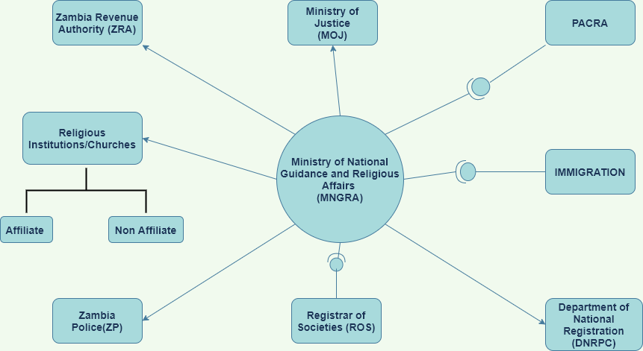

|  |  |
| --- | --- |
|  | **BUSINESS CASE** |

## **PROBLEM STATEMENT**

Explain the problem

## **CHALLENGES THE MINISTRY IS CURRENTLY FACING**

## **BUSINESS VALUE**

Advantages of having this system with respect to enhacing work

# USER REQUIREMENTS

3.1

**RECOMMENDATION LETTER FIG2**

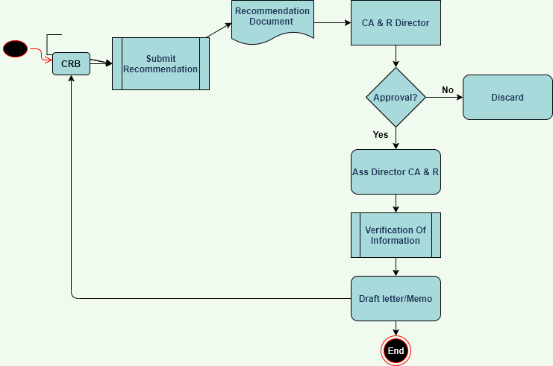

**USER REQUIREMENTS**

|  |  |  |  |  |  |
| --- | --- | --- | --- | --- | --- |
| N**o.** | **User Role** | **Responsibilities** | **Department** | **Position** | **MPSA** |
| 1. | Immigration Department H/A | Writes request for Recommendation | Home Affairs | Commissioner Immigration | Ministry of Home Affairs |
| 2. | Permanent Secretary | Receives request for recommendation letter from Immigration department  Makes comments on the request and sends it CAR Department  Approves Recommendation and sends it to Immigration and Stakeholder | PS’s Office | Permanent Secretary | MNGRA |
| 3. | Director Churches and Religious Affairs | Receives instruction from the PS.  Actions on the instructions given from the PS.  Assigns a directive to the assistance Director CAR  Receives recommendation from Assistant Director CAR | Churches and Religious Affairs | Director | MNGRA |
| 4. | Assistant Director CAR | Receives instruction from the Director  Actions on the instructions given from the Director  Assigns a directive to the Principal / Senior to verify information  Receives recommendation from Principal / Senior | Churches and Religious Affairs | Assistant Director CAR | MNGRA |
| 5. | Principal / Seniors Officers  CAR | Receives instruction from the Assistant Director  Actions on the instructions given from the Assistant Director  Makes Recommendation based on the findings to the Assistant Director. | Churches and Religious Affairs | Principal / Seniors Officers  CAR | MNGRA |

|  |  |  |  |
| --- | --- | --- | --- |
|  | **UR02** | **COMPLAINTS** |  |
| **Outcome to be achieved** | | **Receive a Complaint** | |
| **Stage** | | Complaints from Stakeholders | |
| **Actor** | | **Task** | |
| Churches, religious organisation, Umbrella bodies and public | | * Lodges in a complaint against a Church, Religious Body or Pastors | |
| MNGRA | | * Receives complaint from Individuals, Church or Religious Body * PS actions on the letter and sends it CAR for Investigations * Provides a platform for Mitigation * Recommends to Police for action * PS approves letter and sends to requesting authority | |
| Police | | * Receive recommendation from the Ministry for further action. | |

|  |  |  |  |  |  |
| --- | --- | --- | --- | --- | --- |
| N**o.** | **User Role** | **Responsibilities** | **Department** | **Position** | **MPSA** |
| 1. | Churches, religious organisation, Umbrella bodies and public A | Writes complaint to MNGRA | All Stakeholders | All Stake Holder | All Stake Holders |
| 2. | Permanent Secretary | Receives the Complaint from the Stakeholders  Makes comments on the request and sends it CAR Department  Receives recommendation from CAR department  If it’s a Criminal Offence, the PS sends request | PS’s Office | Permanent Secretary | MNGRA |
| 3. | Director Churches and Religious Affairs | Receives instruction from the PS.  Actions on the instructions given from the PS.  Assigns a directive to the assistance Director CAR  Constitutes a team to intervene with the complaint | Churches and Religious Affairs | Director | MNGRA |
| 4. | Assistant Director CAR | Receives instruction from the Director and coordinates the mediation  Recommends to the Director CAR on the outcome of the mediation | Churches and Religious Affairs | Assistant Director CAR | MNGRA |

|  |  |  |  |
| --- | --- | --- | --- |
|  | **UR03** | **Invitations** |  |
| **Outcome to be achieved** | | **Invitation of the Minister or PS or President** | |
| **Stage** | | Invitation | |
| **Actor** | | **Task** | |
| Churches, religious organisation, Umbrella bodies and public | | * Requests for the attendance of the President, Minister or PS to attend a church function * Receive correspondence from the Ministry. | |
| MNGRA | | * Receive request for attendance of the President, Minister or PS * Due diligence of institution requesting for the attendance of dignitary * If the request is for president, PS sends recommendation to Cabinet Office. * PS approves or rejects the request based on the recommendation | |

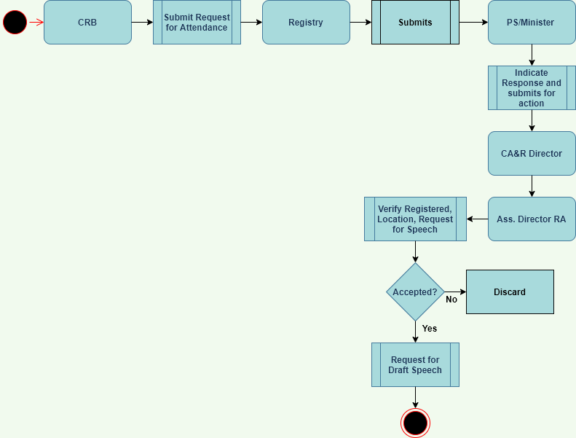

|  |  |  |  |  |  |
| --- | --- | --- | --- | --- | --- |
| N**o.** | **User Role** | **Responsibilities** | **Department** | **Position** | **MPSA** |
| 1. | Churches, religious organisation, Umbrella bodies and public A | Writes to the Ministry to request for President, Ministry or PS | All Stakeholders | All Stake Holder | All Stake Holders |
| 2. | Permanent Secretary | Receives the request for dignitary from the Stakeholders through the registry  Makes comments on the request and sends it CAR Department  Receives due diligence report and recommendation from CAR department  If request is for the President, the PS sends the request to Cabinet Office i.e. SC  Sends speech for the president | PS’s Office | Permanent Secretary | MNGRA |
| 3. | Director Churches and Religious Affairs | Receives instruction from the PS.  Actions on the instructions given from the PS.  Assigns a directive to the assistance Director CAR  Receives due diligence report from ASS-Car | Churches and Religious Affairs | Director | MNGRA |
| 4. | Assistant Director CAR | Receives instruction from the Director and instructs team for Due diligence  Recommends to the Director CAR on findings  Prepares Speech for the Invited person | Churches and Religious Affairs | Assistant Director CAR | MNGRA |

|  |  |  |  |
| --- | --- | --- | --- |
|  | **UR03** | **Invitations** |  |
| **Outcome to be achieved** | | **Recommendation Letter TAX Rebate** | |
| **Stage** | | Tax Rebate | |
| **Actor** | | **Task** | |
| Churches, religious organisation, Umbrella bodies and public | | * Request for recommendation for a TAX Rebate from the MNGRA | |
| MNGRA | | * Receive request for Tax rebate * Due diligence of institution requesting for Tax Rebate * PS approves / Denies request and sends response to requesting authority and stakeholder | |

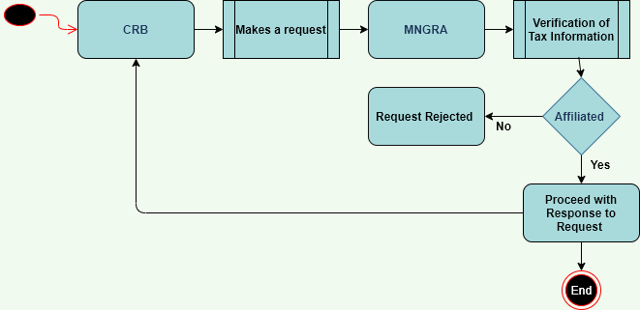

|  |  |  |  |  |  |
| --- | --- | --- | --- | --- | --- |
| N**o.** | **User Role** | **Responsibilities** | **Department** | **Position** | **MPSA** |
| 1. | Churches, religious organisation, Umbrella bodies and public | Writes request for TAX rebate from MNGRA | Stakeholder | Stakeholder | Stakeholder |
| 2. | Permanent Secretary | Receives request for Tax rebate letter from stakeholders  Makes comments on the request and sends it CAR Department  Approves / rejects the request and sends it to MOF and Stakeholder | PS’s Office | Permanent Secretary | MNGRA |
| 3. | Director Churches and Religious Affairs | Receives instruction from the PS.  Actions on the instructions given from the PS.  Assigns a directive to the assistance Director CAR  Receives recommendation from Assistant Director CAR | Churches and Religious Affairs | Director | MNGRA |
| 4. | Assistant Director CAR | Receives instruction from the Director  Actions on the instructions given from the Director  Conducts Verification on Tax Information  Generates recommendation Letter for Tax Rebate and send to Director CAR | Churches and Religious Affairs | Assistant Director CAR | MNGRA |

COMPLAINTS

* PS receives recommendation letter from CRBs
* PS makes comments and sends it to the department of CAR
* The department of CAR receives a recommendation letter from PS
* Senior religious officer verifies information
* A letter is drafted and sends to the PS
* PS approves letter and sends to Immigration

### **EXISTING ICT SYSTEM**

|  |  |  |
| --- | --- | --- |
| **Institution** | **System** | **Status of System** |
| **PACRA** |  | Present and Running |
| **Registrar of Societies** |  | Phase 2 of System under construction |
| **Immigration** |  | Present and Running |
| **Department of National Registration (DNRPC)** | Integrated National Registration Information System (INRIS) |  |
| **Zambia Police** | e-Policing System |  |

## **STAKEHOLDER LIST**

|  |  |
| --- | --- |
| **INSTITUTION** | **ROLES AND RESPONSIBILITIES** |
| **MNGRA** | * Have files for each stakeholder (information is as received from CRBs) * Issues guild lines for CRBs (Church rand Religious Bodies) * Collaborates with CRBs on various programmers the ministry is undertaking * Manages churches that are not affiliated with mother bodies * Gets information on CRB from Registrar of society * Receives complaints from CRBs and the Public * Advise the complainant to refer the matter to relevant authorities * Consults Registrar of Society about the authenticity of CRBs * Recommends to immigration about the authenticity of CRBs * Constitutes a committee to deal with CRBs issues * Trainings for chaplains * Makes recommendations for Fund empowerment for vulnerable |
| **Registrar of Society** | * Has a system that registers CRBs * System has a database of all CRBs not online * Registration of CRBs is done by an application form which is later entered into the system * The system accepts applications from applicants who are endorsed by their umbrella bodies and should have 10 NRCs and 10 finger prints and certified copies for CRB. Branches do not require Fingerprints. * Qualifications of the overseer is a prerequisite for the application * The system provides various reports |
| **Evangelical Fellowship of Zambia** | * Makes Recommendations for their church members to Register * Certified copy for registrar * An original copy of the constitution * Copy of statement of faith * Academic and professional qualifications * 2 letter of recommendation form EFZ in good standing * Written testimony of salvation * Certified copy of certificate from registrar of societies. |
| **Hindu Association of Zambia** | * Advise respective associates to register with the registrar of societies * General welfare of the associates * Have a register of associates |
| **Islamic Supreme Council of Zambia** | * ISCZ is the umbrella body of Muslims in Zambia * Makes Recommendations for institutions to register with the registra of societies * Have a system to capture members |
| **Makeni Islamic Society Trust** | * Makes Recommendations for their association to register * Does not have affiliations, has branches in various areas run by the society. * Makeni runs 6 Mosques from Central Province to Southern * Educational institution from Early Childhood to college * Work with Government under DMMU relief * Prisons welfare in Zambia * Drug awareness in prisons and schools * Makeni Islamic clinic * Famer input support programme * General welfare of community ( through donations) |
| **Lusaka Muslim Society Trust** |  |
| **Independent Churches of Zambia**  **(ICOZ)** | * Makes Recommendations for their prospective affiliates to Register * Requirement for Recommendation ( Bible school Certificate, Ordination Certificate, Transcript from Bible school, constitution * Recommendation from ICOZ Church already affiliated to ICOZ * Inspection by the Bishop * Work with DMMU * Records are kept Manually for each church |
| **Christian Brethren**  **CMML** | * Do not belong to any mother body * Group of a number of churches * Run hospitals and schools * Provide the certificates for exemption * One church gives birth to another * Any church born is autonomous * All churches use only one constitution * Data is kept manually * Run a Handicapped school in Luapula * Liaison Office- Interface between government and CMML with 3 Officers |
| **Apostles Council of Churches** | * Makes Recommendations for their prospective affiliates to Register * Church should be registered with Registra of society for affiliation * Receive a copy of the Constitution of the Church * Undertake feasibility study of a church * Qualification of the Pastor – for ordination / training * Issues Affiliation Certificate * Offer induction courses * Offer ordination programmes * Offers licensing ministers |
| **Seventh Day Adventist Trust** | * Makes Recommendations for their church members to Register * Managed by the SDA Trust * Divided into Northern and Southern Region * Each Region is divided into Conferences who management various churches * Schools and hospital report to the union |
| **Ministry of Justice** | * Chairs the clusters of governance issues * Provides MNGRA legal advice in regard to CRB |
| **Ministry of Chiefs and Tradition Affairs** | * Identifies the chaplains |
| **Zambia Police** | * Receives criminal offences reports committed by CRBs from MNGRA |
| **Ministry of Defence** | * (Chaplain General’s Office; collaborates with MNGRA when need arises * Military chaplains accord a state ecclesiastical function a ceremonial appearance * Chaplain General’s Office; advises the government on moral and religious matters |

### **3.4.1 System Security Standards**

|  |  |  |  |
| --- | --- | --- | --- |
| ID | Sub-quality | Requirement | Priority |
| 1 | Audit Trail | The system will keep history of all changes by user | High | |
| 2 | Data privacy | Prevent sensitive information from being printed, forwarded, or copied by unauthorized people | High | |
| 3 | Data Classification | Classification of data based on its level of sensitivity | High | |
| 4 | User Access | 1. User credentials should, at a minimum, comprise **User ID** and **password** which restrict what functionality the User can access on the system. The password in particular MUST comprise Characters, number and special characters. 2. The solution should enforce **password formats** and **standards**. 3. The solution should provide for individual user and user group access. The solution should further provide for a system Admin function, which is only accessible to authorised users while other users are restricted to only functions that they require for their role on the system. | High | |

### **3.4.2 Scalability**

|  |  |  |  |
| --- | --- | --- | --- |
| ID | Sub-quality | Requirement | Priority |
| 1 | Automatic Scaling | The system must be accessed by more than one user simultaneously | High |
| 2 | Traffic  Management  Load Balancing | Users must access the system with the Government Wide Area Network with acceptable response times. | High |

### **3.4.3 Maintainability**

|  |  |  |  |
| --- | --- | --- | --- |
| ID | Sub-quality | Requirement | Priority |
| 1 | Master Data Management | The system should enable the management of all major entities | High | |
| 2 | Data Archiving | The system should be able to archive the data after a period and limit the access to this data. | High | |

### **3.4.4 Usability**

|  |  |  |  |
| --- | --- | --- | --- |
| ID | Sub-quality | Requirement | Priority |
| 1 | Interface  Language | * The default languages are:   + English (ISO 639-1: EN) | High |

|  |  |
| --- | --- |
| **4** | **SERVICE AND SUPPORT** |

## **END-USER OPERATIONAL SUPPORT**

The solution should define a service model that will ensure comprehensive and timely service to the Board. The model should provide detailed support mechanisms. These should cover, but not be limited to, the following;

* The solutions should enable institutions to reduce costs and add value by improving the effectiveness of operations to enhance the quality and quantity of work performance. Technical problems can disrupt an otherwise efficient operation,and can be compounded when there is no dedicated support available.
* Users of the system need to be provided with 24/7 on-call support to troubleshoot issues, manage data backup and recovery, and provide installation and upgrade assistance.
* Operational plans need to be established detailing helpdesk procedures and policies, recommendations for management software solutions based on industry best practices, and processes for tracking and codifying reoccurring issues for global response within customer operations.

## **DOCUMENTATION**

System documentation is a vital and important part of successful software development. Documentation is designed to inform the reader about the software and describe how it was created, what it is intended to do and how it works. It should also be easy to find or access, and it should have the ability to be updated as changes are made to the software over the course of time. While details have to be included for documentation to be properly comprehensive and effective, the goal is for all computer software documentation to be written in language that’s fairly easily understood. The following types of documentation shall be made available:

* **User Documentation**; the solution will provide a user manual that system users should read to understand the requirements and operations of a software system so they can then download it and use it. Types of user documentation include training manuals, user manuals, release notes and installation guides.

User documentation can also include system requirements so that the users understand whether or not their system will be able to handle the software.

* **System Documentation**; is geared toward an advanced or specialized reader, such as a systems administrator or IT professional, includes things like **source code, testing documentation and API documentation** (programmers’ documentation or instructions).

It describes the requirements and capabilities of the software and informs the reader about the functionality of the solution. **Technical Specification** is a type of system documentation document describes the capabilities and characteristics of the system for a technical user. Technical documentation can include coding for the software and a record of how it was designed, such as the architecture of the creation and the goals of designing the software and each of its aspects.

## **SOFTWARE MAINTENANCE & UPGRADES**

Modification of a solution after delivery to correct faults, to improve performance or other attributes is required. Maintenance of a solution will involve fixing defects and enhancements to the system. Following are some types of maintenance based on their characteristics:

* **Corrective Maintenance** - This includes modifications and updates done in order to correct or fix problems, which are either discovered by user or concluded by user error reports.
* **Adaptive Maintenance** - This includes modifications and updates applied to keep the software product up-to date and tuned to the ever-changing world of technology and business environment.
* **Perfective Maintenance** - This includes modifications and updates done in order to keep the software usable over long period of time. It includes new features, new user requirements for refining the software and improve its reliability and performance.
* **Preventive Maintenance** - This includes modifications and updates to prevent future problems of the software. It aims to attend problems, which are not significant at this moment but may cause serious issues in future.

|  |  |
| --- | --- |
|  | **COSTING PARAMETERS** |

## **SOFTWARE LICENCING**

An open source can be considered

## **IMPLEMENTATION PLAN**

**ROADMAP FOR THE IMPLEMENTATION OF CHURCH AND RELIGIOUS BODIES MANAGEMENT INFORMATION SYSTEM**

|  |  |  |  |  |  |  |  |
| --- | --- | --- | --- | --- | --- | --- | --- |
|  | **Activity** | **Start Date** | **End Date** | **Duration** | **Responsible** | **Output** | **Status** |
| **1** | Concept Note | June 2020 | June 2020 | 1 Week | MNGRA | Approve Concept Note Document | **Completed** |
| 2 | Feasibility Study | 1 June 2020 | 15th June2020 | 2 Weeks | MNGRA | Feasibility Study Report | **Completed** |
| 3 | Business Requirements | 7th Sept 2020 | 18th July2020 | 2 Weeks | MNGRA and SZI | Business Requirement Document | **90% completed** |
| 4 | System Requirements | 28th Sept | 2nd Oct | 1 week | SZI | System Specification Requirement Document | 0% completed |
| 5 | Developing of a Prototype | 28th Sept | 9th Oct | 2 weeks | SZI, Registra of Societies, Pacra | CRBMIS Prototype | 0% completed |
| 6 | Systems Development | 9th Oct | 16th Oct | 1 week | SZI | Fully Developed CRBMIS | 0% completed |
| 7 | User Acceptance Testing | 19th Oct | 23rd Oct | 1 week | SZI, MNGRA | Tested CRBMIS | 0% completed |
| 8 | Training | 26th Oct | 27th Oct | 2 days | SZI, MNGRA, stakeholders | System users trained | 0% completed |
| 9 | Deployment and commissioning | 2nd November |  | 1 day | MNGRA | Web based CRBMIS | 0% completed |

## **TRAINING**

Budgets will be required to train the would be users of the solution. Each institution involved should identify the people that should receive training. A venue to conduct training should also be made available. If need be travel costs and accommodation should be budgeted for.